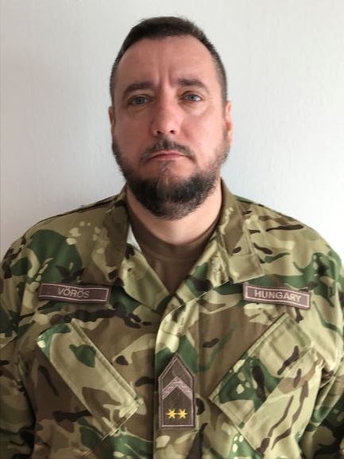
Balázs Vörös chief warrant officer
Address:1101 Budapest, Hungária krt. 9-11.
Email:voros.balazs@uni-nke.hu
Phone: +361 432 9000 / 29-461
Place and Date of Birth:Celldömölk 1975.10.06.
Nationality:Hungary

PROFESSIONAL EXPERIENCE
1993.- 1995. Kossuth Lajos NCO Traning school, Military College.
1995.- 1997. 5. Csobánc MRL Artillery Regiment 1. MRL Department 2. Battery, NCO suppiler.
1997.-2000. 101. „Szigetvári” Zrínyi Miklós Artillery Brigade 1. MRL Department 2. Battery 2. platoon NCO.
2000.- 2002. 1. MRL Department 2. Battery, NCO.
2002.- 2004. Traning Directorate, traning NCO.
2004.-2005. 64. Boconádi Szabó József Logistics Regiment, Operational Directorate, operational NCO.
2005.- 2012. Zrínyi Miklós University of National Defece, Kossuth Lajos Faculty of Military Science and Officer Traning, Department of Artillery, instructor.
2012- National University of Public Service, Kossuth Lajos Faculty of Military Science and Officer Traning, Department of Operational and Support, instructor.

EDUCATION
1993. Várpalota, Faller Jenő Skilled Worker School
1995. Szentendre, Kossuth Lajos Military College
1999. Budapest, Military College
2003. Pécs, ECDL Course
2013. Szentendre, NCO school, Operational and Traning course

STUDIES AND DEGREES
0000–0000
0000–0000
0000–

OTHER ACADEMIC AND PROFESSIONAL ACTIVITIES
0000–0000
0000–0000
0000–

LANGUAGE SKILLS
English | C

